Tugas Evaluasi II Makassar, 14 Oktober 2024

**PRAKTIKUM**

**STRUKTUR DATA**

Nama : Andi Ikhlas Mallomo

Stambuk : 13020230251

Frekuensi : TI_SD–7 (A7)

Dosen : Syariful Mujaddid, S.Kom., M.T.

Asisten 1 : Annisa Pratama Putri

Asisten 2 : Rahma Puspitasari

**PROGRAM STUDI TEKNIK INFORMATIKA**

**FAKULTAS ILMU KOMPUTER**

**UNIVERSITAS MUSLIM INDONESIA**

**MAKASSAR**

**2024**

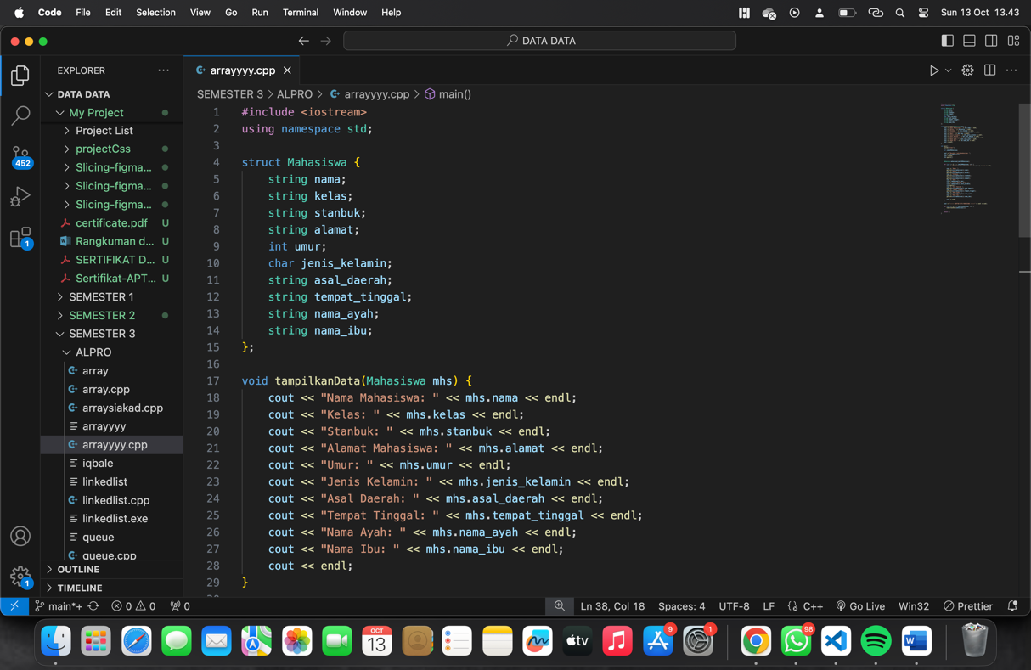

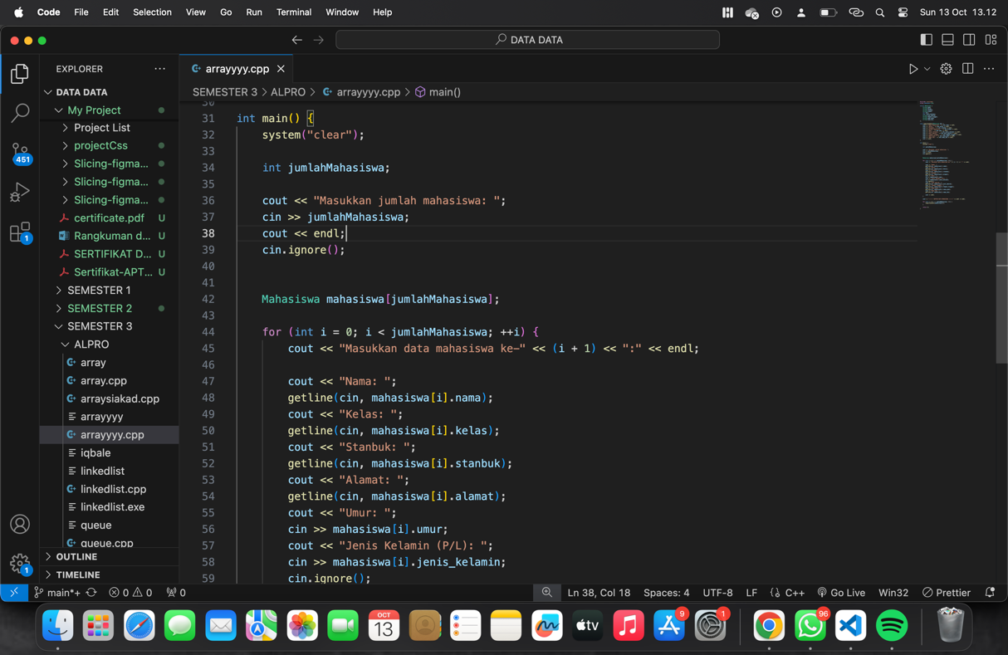

Top of Form



